TABLEAU ASSIGNMENT REPORT
Global & Nation Data Analysis Using Tableau
Name: CHANDANA A
USN: 1VI23CD010
Assignment Objective
Analyze global and national datasets to identify insights related to:
- Death Rate
- Population Growth
- Prominent Cities with High Populations
- Coastal vs Non-Coastal Cities
- Hierarchical Geographic Relationships
- Continental Population Distributions
- Symbol Maps and Map Layers
Create:
- 12 Individual Worksheets (Sheets 1–12)
- Final Dashboard
- Story Presentation

Step-by-Step Implementation Guide

Step 1: Data Connection & Preparation
Connected Two Datasets:
- GlobleData.xlsx
  - Continent, Country, Region
  - Population 2018, 2019
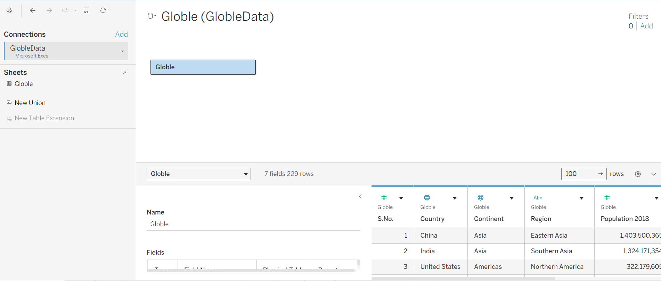

- NationData.xlsx
  - CityName, State
  - Birth Rate, Death Rate
  - Population Current
  - COASTAL (Group created)
Both datasets were verified and cleaned. Geographic roles were assigned to:
- Country → Country/Region
- Clean City → City
This ensured correct mapping in Symbol and Filled Maps.

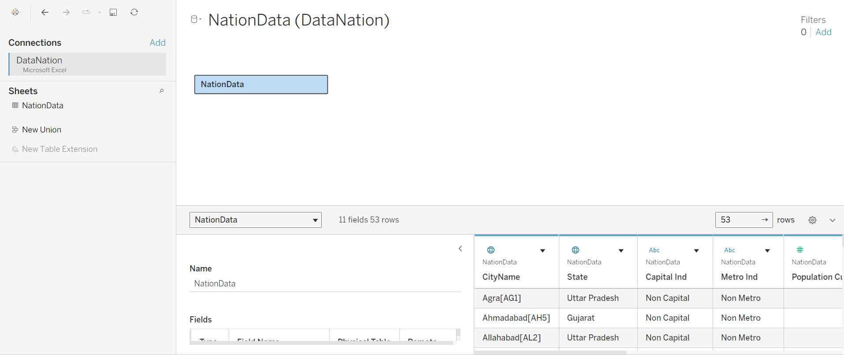

Step 2: Sheet 1 — Death Rate in Colors
- Use NationData
- Double-click Latitude & Longitude
- Drag CityName → Detail
- Drag Death Rate → Color
- Select Red-Green Diverging palette
Insight: Higher death-rate cities appear in dark/red shades.
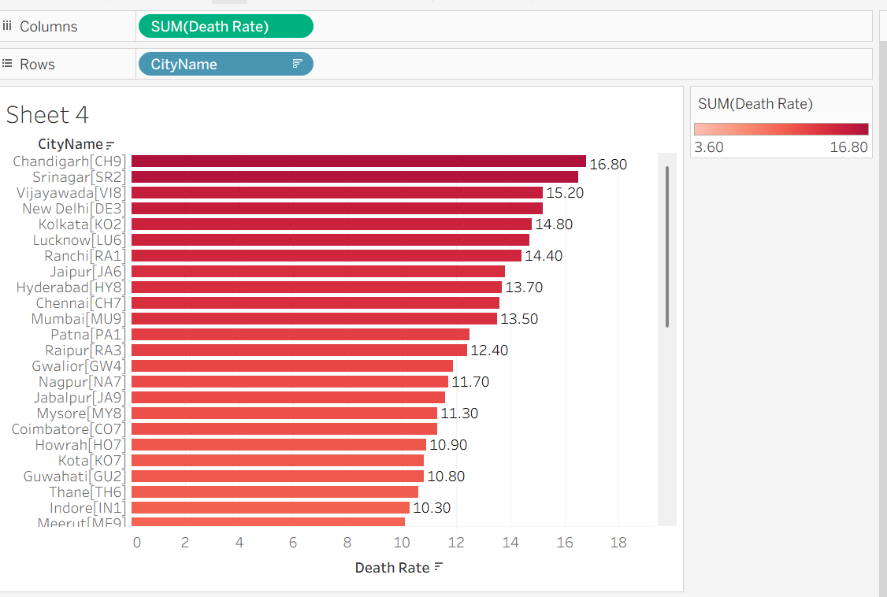

Step 3: Sheet 2 — Population vs Death Rate (Dual Axis)
- Region → Columns
- Population 2019 → Rows
- Death Rate → Rows → Right-click → Dual Axis
- Synchronize Axis
- Apply two different colors
Insight: Regions with higher death rates often correlate with lower population density.
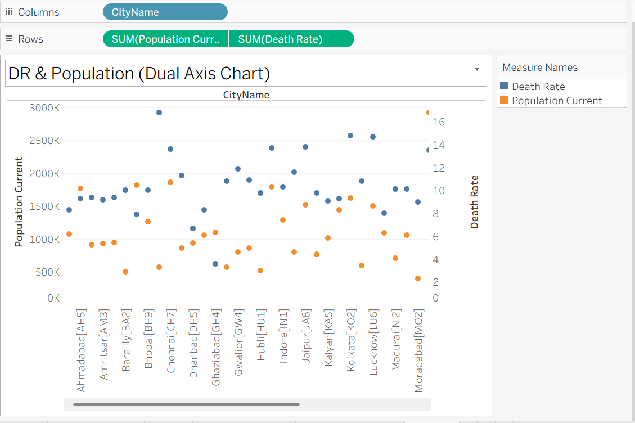

Step 4: Sheet 3 — Prominent Cities with High Population
- CityName → Rows
- Population Current → Columns
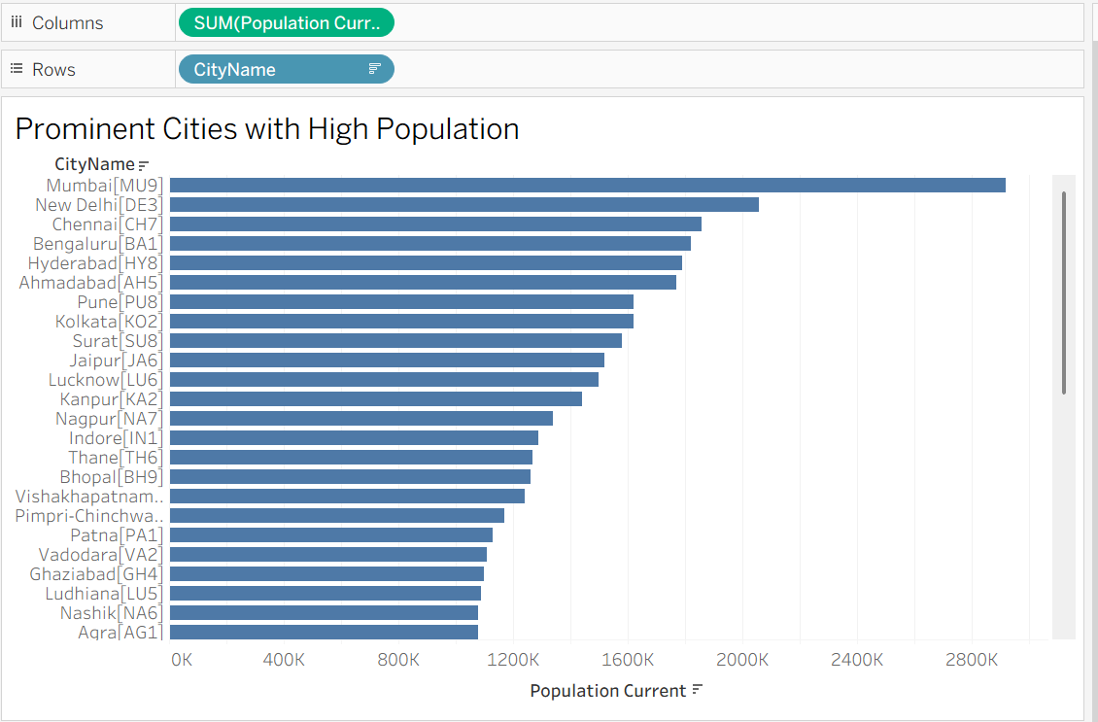

Step 5: Sheet 4 — Death Rate of Cities
- CityName → Rows
- Death Rate → Columns
- Sort descending
- Add labels
Insight: Identifies cities with the highest mortality rate.
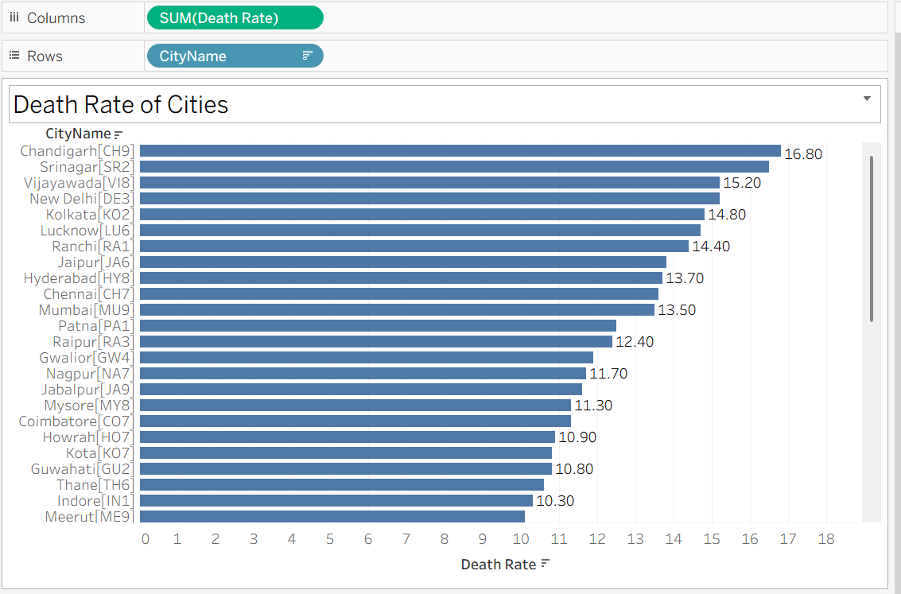

Step 6: Sheet 5 — Create Coastal Cities Group
- Select coastal cities manually
- Right-click → Group
- Rename to “COASTAL”
Insight: Enables classification of cities into Coastal vs Non-Coastal.
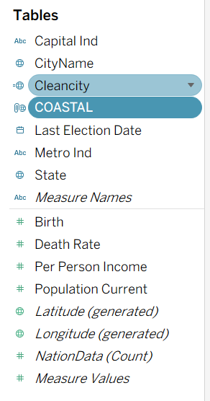

Step 7: Sheet 6 — Filter on Coastal Cities
- Build basic chart (City vs Population)
- Drag COASTAL → Filters
- Show Filter
- Allow switching between groups
Insight: Allows quick isolation of coastal populations.
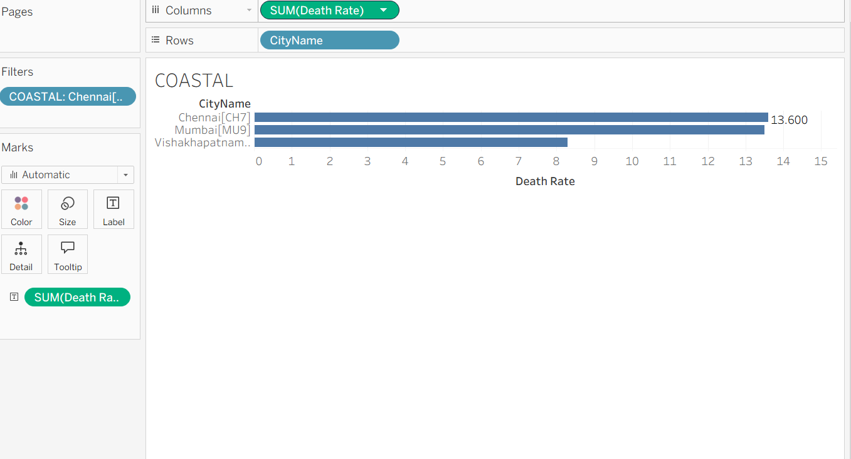

Step 8: Sheet 7 — Map Layers Customization
- Plot Clean City on map
- Open Map → Background Layers
- Modify:
  - Style (Light/Dark)
  - Borders
  - Coastlines
  - Terrain
  - Land Cover
Insight: Enhanced map visualization for clearer geographic analysis.
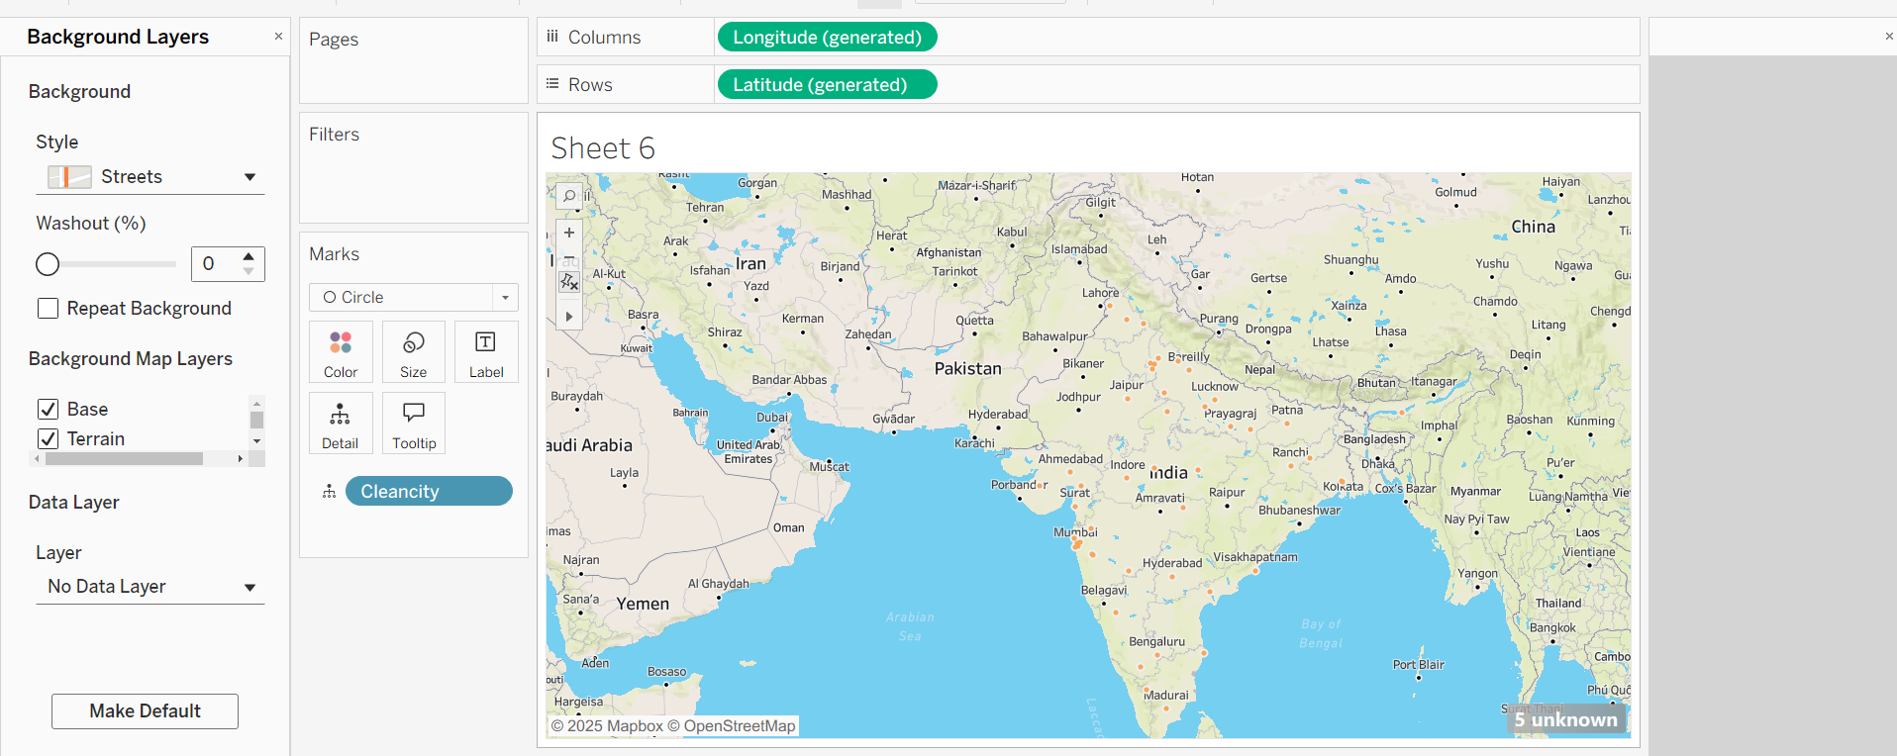

Step 9: Sheet 8 — Using Global Data
- Switch to GlobleData
- Region → Rows
- Population 2019 → Columns
- Title: “Using Global Data”
Insight: Confirms proper usage of global dataset.
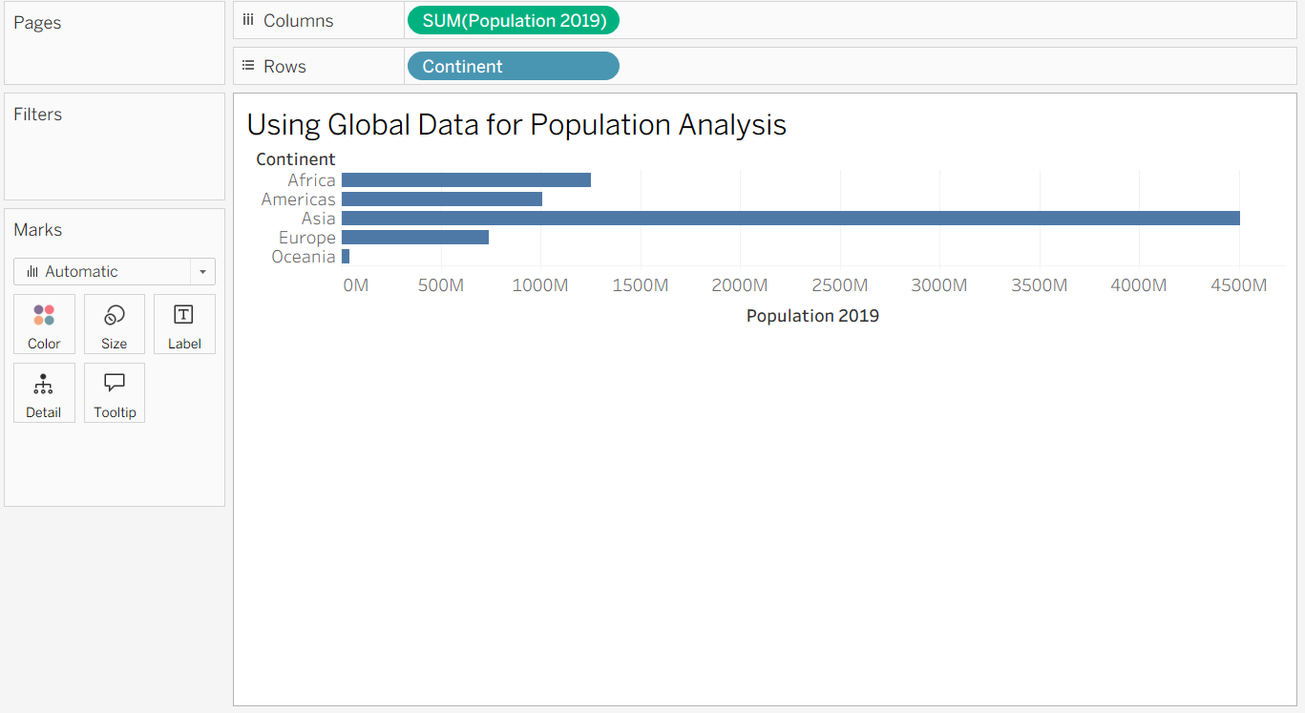

Step 10: Sheet 9 — Geographic Hierarchy
- Right-click Continent → Create Hierarchy
- Add Country and Region
- Build drill-down bar chart
Insight: Enables navigation from Continent → Country → Region.
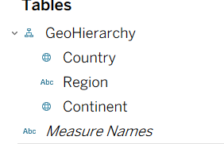

Step 11: Sheet 10 — Continent with Different Population (Symbol Map)
- Build map using Country
- Drag Continent → Color
- Population 2019 → Size
- Continental patterns are highlighted
Insight: Shows population distribution across continents.
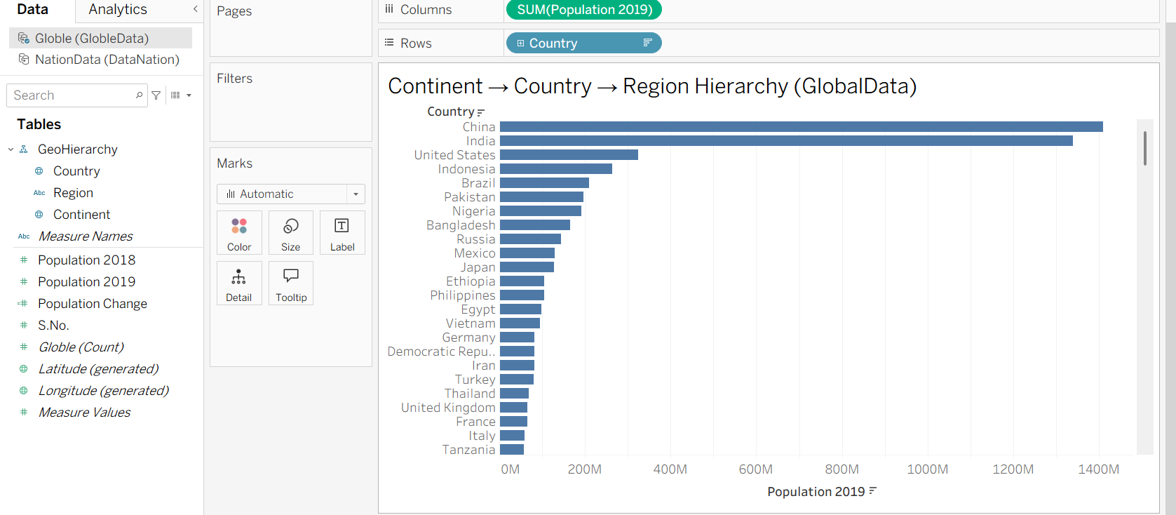

Step 12: Sheet 11 — Different Symbols
- Continent → Shape
- Change Marks → Shape
- Assign different icons to each continent
Insight: Unique symbols help differentiate regions visually.
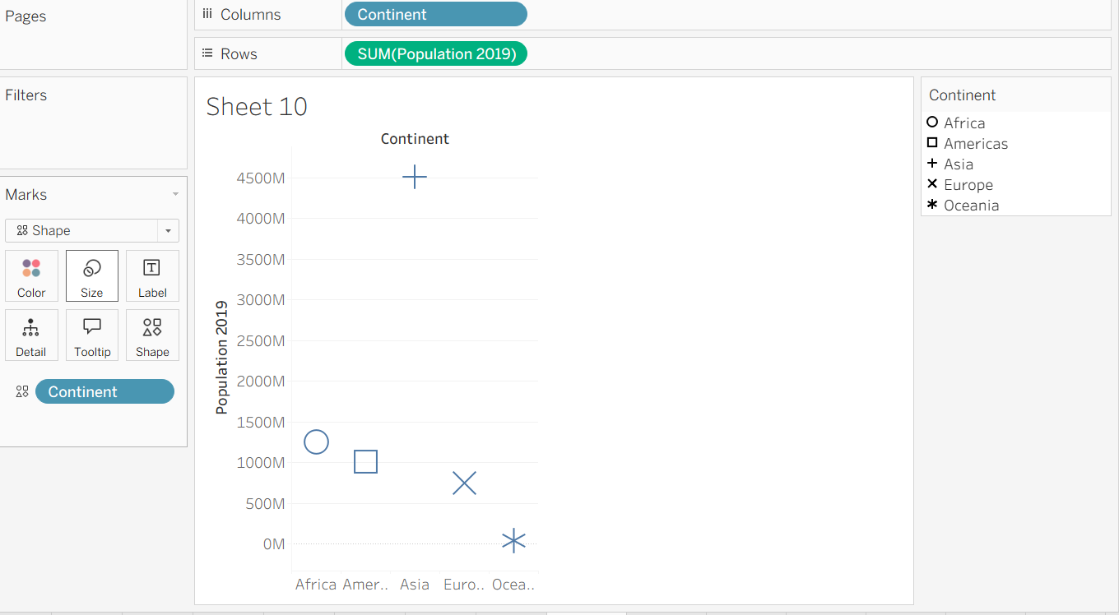

Step 13: Sheet 12 — Increase/Decrease in Population
- Create Calculated Field:
Population Change = Population 2019 – Population 2018
- Region → Rows
- Population Change → Columns
- Color to highlight positive/negative
Insight: Identifies regions with population growth or decline.
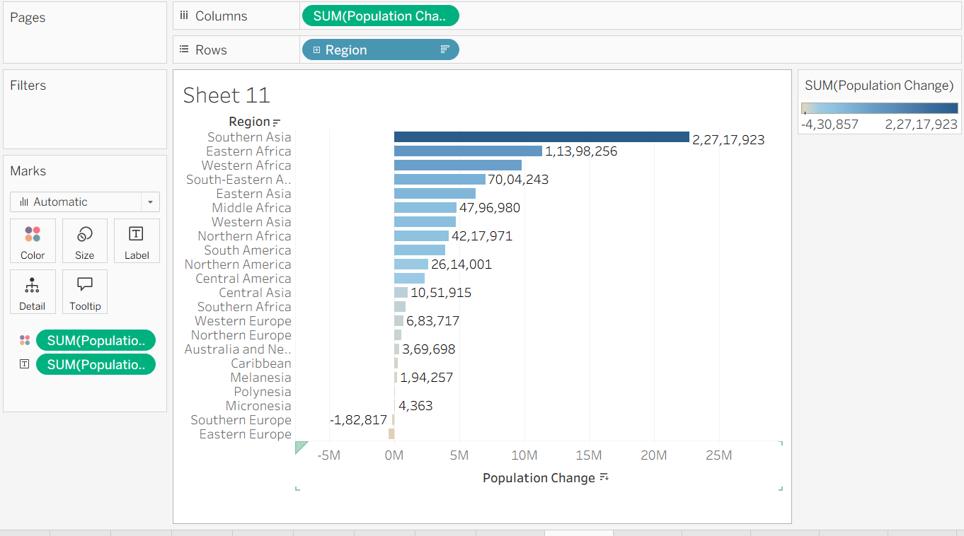

Step 14: Dashboard Creation
